Article for Church News
WATER MAKES THE WORLD GO ROUND
A GREAT COLLECTIVE EFFORT FROM CHURCHES IN KINGSTON AND SURBITON, THAT CERTAINLY MADE A SPLASH IN KINGSTON!
Due to Covid restrictions the Kingston Christian Aid (CA) group had to think of something fresh and new for their fundraising for Christian Aid Week, rather than deliver and collect envelopes etc. under their slogan' Water Makes the World Go Round', we persuaded Lesley and another 5 Ministers and Vicars to Walk approx. 5 miles every day for 6 days, whilst carrying 2 Buckets of water.
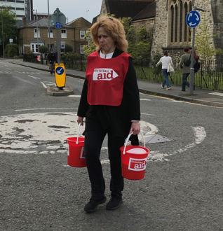

Not only that; they start with 1 Litre in each Bucket and each day increase this by 1 Litre/day, so by Saturday 15th May, they will be carrying 6 Litres is each bucket (+6KG) when walking the circular route, which takes in their churches of St Matthews and St. Marks (Surbiton) and All Saints, St. Johns, the United Reformed and Methodist Churches of Kingston.

Rev. Lesley Charlton of the URC says "When Ray told me HE had committed me to carry 2 buckets of water for 30 miles, after thinking of a few swear words, I realized that this was an excellent witness to our sisters and brothers who daily have a struggle to access water, a basic need of life".
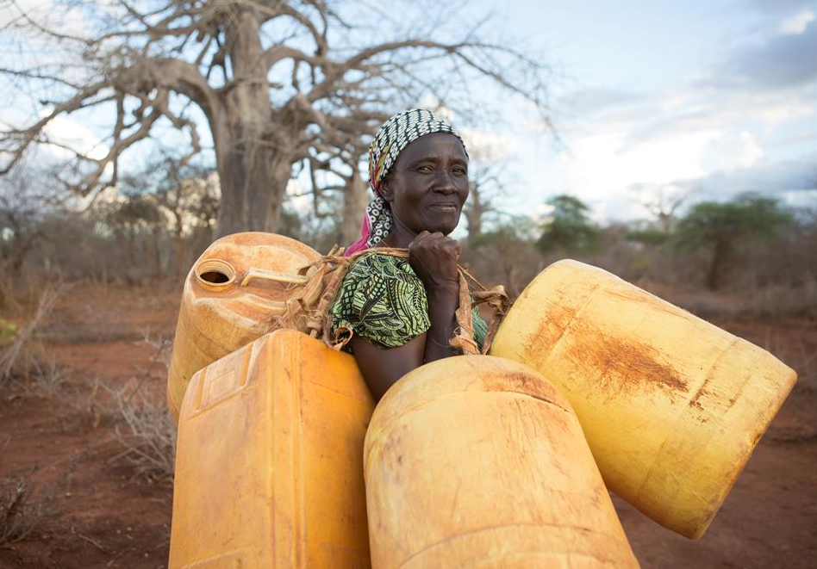
The Kingston CA Group decided upon this activity , as it links into CA's own campaign, about Climate Change and the hardship and chaos it is causing for the poorest.
Left is Rose in Kenya, with her containers going to earth dam.
Below are Rev. Mark Stafford and his wife Lucy; Rev. Jonathan Wilkes, Rev. Helen Hancock, Rev. DR. Karl Rutlidge and Rev. Robert Stainer.

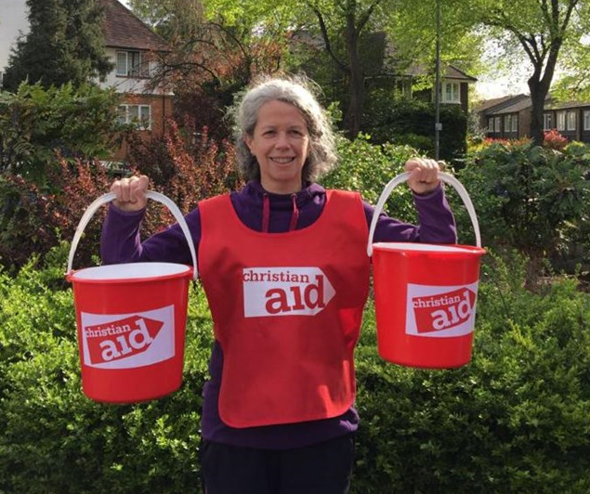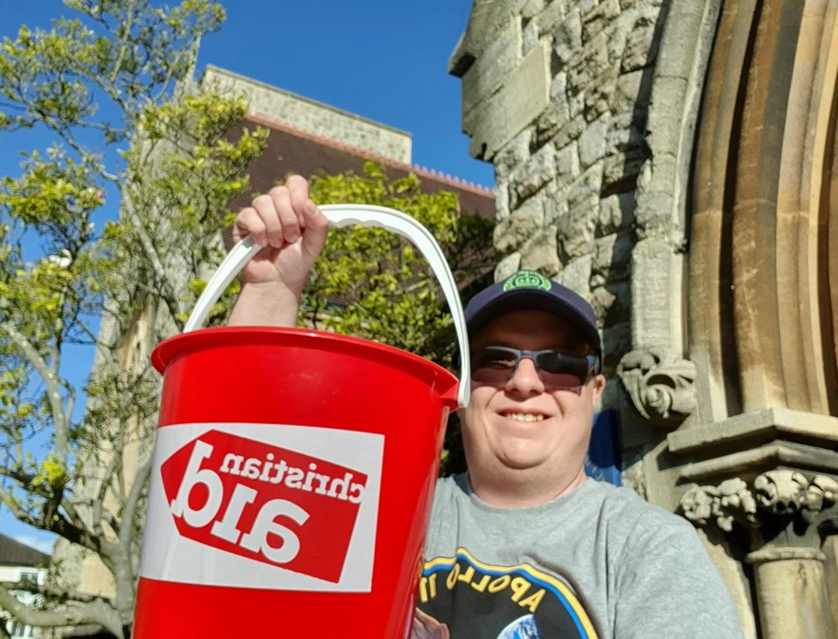
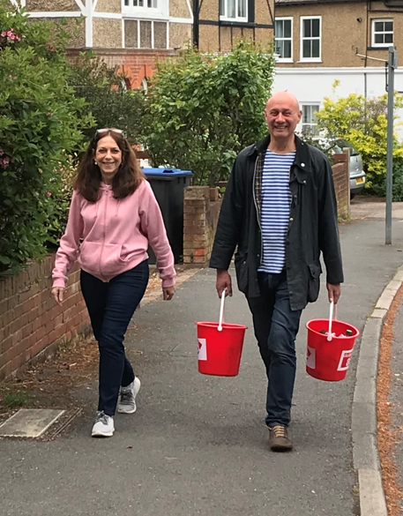
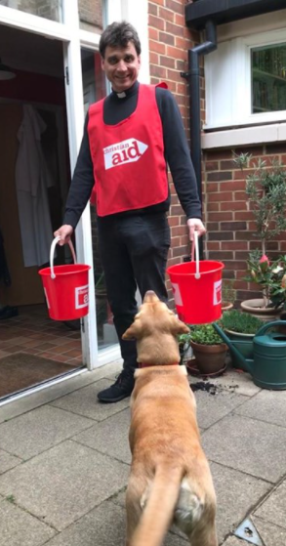
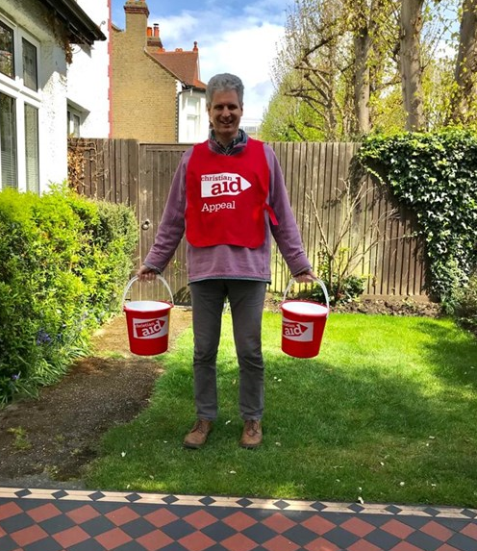
The group concluded the Walk on Saturday 15th May, in Clarence Street Kingston Upon Thames, where they had socially distant singers, The Canbury Sound singing some uplifting Water Based Songs, encouraging the public to give to the collectors with their buckets.

The Highlight of the day was, The Mayor of Kingston, Margaret Thompson, who was there to greet the Walkers when they returned on their last lap of the 5 mile circuit.
Our Mayor, Margaret Thompson, with Helen, Karl, Lesley and Jonathan. Unfortunately, Mark and Robert could not attend the finale but had completed their 30miles.
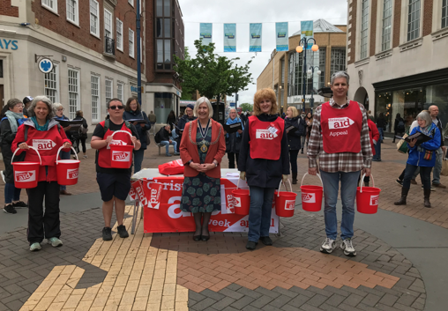
After all the walkers were clapped in, the Mayor graciously accepted a Shower or Deluge, from our walking team.
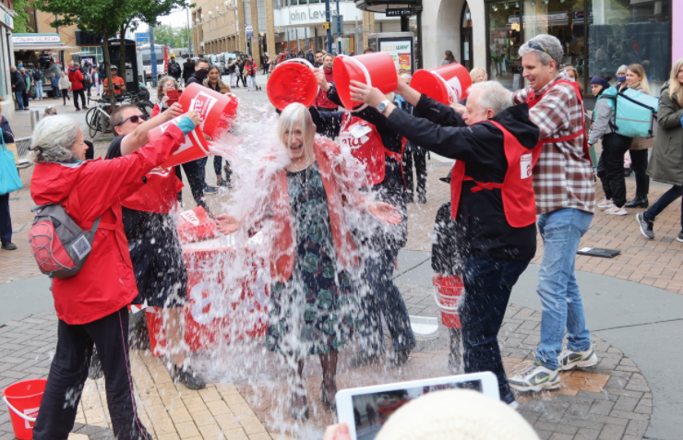
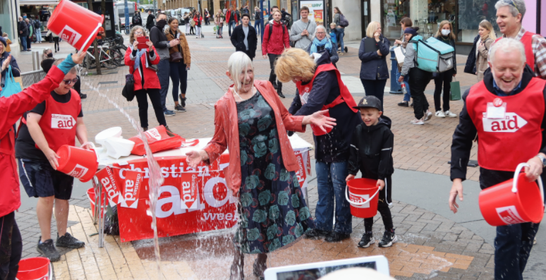

Three Cheers for the Mayor, who helped us attract a crowd, helping the fundraising and also we hope awareness of Christian Aid and work they do.
We are so pleased with the response of the public to this Fundraising initiative, we even have children doing their own bucket carrying challenge as they are so aware and concerned about the damage Climate Change is having and work that Christian Aid is doing to help.
It is important people know that we want to help tackle hardship, injustice and the impact of climate change experienced by the world’s poor, irrespective of race or religion.
Many, many thanks go to all the work put in by the Christian Aid Committee and of course, the 30 miles of slog by the walkers.
If you have not yet donated but would like to, please donate via https://www.justgiving.com/fundraising/kingstonchurches
Ray Charlton

