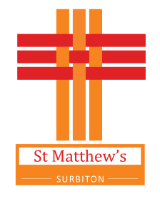

Location warning notice -
live-streaming taking place here

Please be advised that our church services are now live-streamed to Facebook and our YouTube Channel
(‘StMatthewsChurchSurbiton’).

You will not appear in any shots if you remain in the pews (from the third pew back) or at the back of church. You may appear briefly if you are at the front receiving Holy Communion.

If you do not wish to appear in any images please ensure that you sit towards the back and inform a Churchwarden or sidesperson. If it is a Communion Service and you wish to receive Communion we will arrange for it to be brought to you, provided you have advised a Churchwarden or sidesperson before the beginning of the service.

By attending our services, you are presumed to have given consent to these arrangements.

Thank You

