Top Tips on Family Worship at Home
Whilst our usual pattern of Sunday service and Junior Church is put on hold, we hope to resource households to continue to worship and pray together and be a place of Christ’s light in our world during these uncertain days.
Here are some top tips to get started:
1) Find a time in the day that works for you.
2) Don't expect it to be silent - it will be messy! Go with the flow.
3) Encourage everyone to contribute, both adults and children.
4) Be flexible on timing and ready to adapt or shorten the session if your children get restless - there’s no point in making this a battle! 5) Use the events of the past few days to explore where you've each met God or seen him at work.
6) Involve your children and young people with what the church is doing during this CV-19 crises – suggestions can be found in the Action section.

A Junior Church session for Mothering Sunday for households
Big Idea: Thanking God for the people who care for us
Starter activity: Brainstorm a list of all the people who look after you, including names where you can. These could be people in your family, at school, or our public services.
Bible Story: Here’s a Bible story about a mother and sister that looked after a baby during a difficult political time.
Older children might like to read: Exodus 2:1-10.
For younger children, the story is found in The Barnabas Classic Children’s Bible (Rhona Davies) p.42: Moses and the Princess of Egypt.
Or you might like to watch this Godly Play retelling of the story here
Discussion:
Choose a few of these questions to get a discussion flowing:
I wonder…?
What do you like best about this story?
What’s the most important part of this story?
Is there any part of this story we could leave out and have all that we need?
How do you think the mother and sister of Moses felt when they had to leave him in the basket?
Why did Pharaoh’s daughter disobey her father’s instructions and rescue the baby?
Who can we help today?

Creative Prayer Activity:
Adapt this idea from Flame Creative Kids to help children think about the love shown to them by their mothers, grandmothers, and/or people who look after them. As you make the envelope out of a heart, chat about all the demonstrations of love shown to us. Then fill the envelope with little messages, thanking the intended recipient for loving us in all these different ways. Finally, seal the envelope and give it/send it to the mother, grandmother or whoever looks after us. Alternatively, children could do this for other significant women in their lives – a children's worker, a neighbour or someone at school.
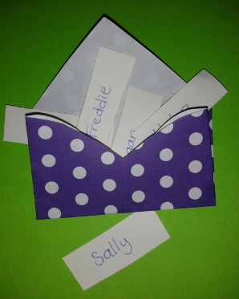
Pray for the people you will send the envelope to.

Remember to send your letters and to keep praying for these people throughout the week.
You could also phone or video call an older relative or member of the congregation who may be self-isolating, and maybe share this Bible story with them.

