

**How can I look after my mental health?**

Firstly, if you are on medication, always follows your doctor’s advice.

Secondly, seek help if low moods and anxiety continue for some time, follow the link

Thirdly, there are also things we can all do to help ourselves during times of stress…like the ’10 A Day’ Choices Challenge!

**Key question:** Are we able to manage our own mental health?

**Looking after your mental health and wellbeing during stressful times**

**What is mental health?**

It is ‘a state of wellbeing in which an individual realises his or her **own abilities**, can cope with the **normal stress of life**, can work **productively** and is able to **make a contribution** to his or her community’ *World Health Organisation, April 2016*

**Who has mental health?**

We all have it. Some of us find we need to pay **more attention** to it at certain times than others. Some people have periods of good as well as poor mental health.

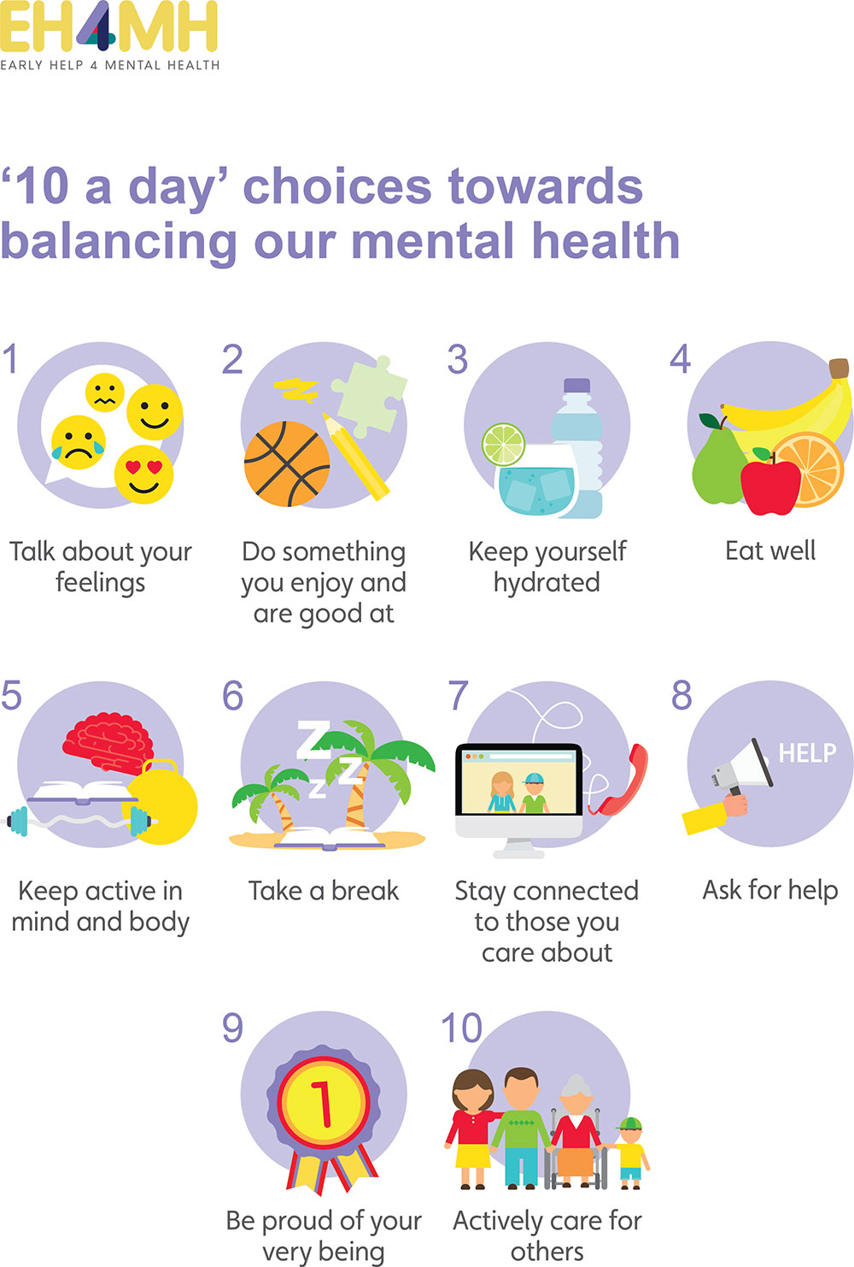



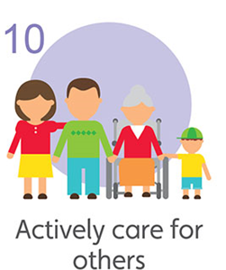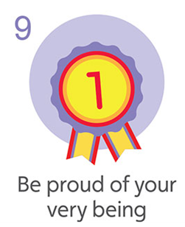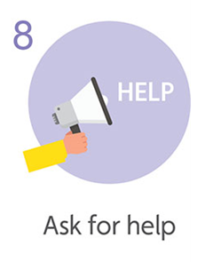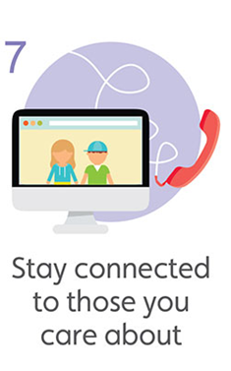

Take the

**‘10 a Day’**

**Choices Challenge**



1. **Be proud of your very being** – you are worth taking care of. Ensure your environment reflects this. Have periods when you keep your windows open to let in fresh air, get some natural sunlight if you can, or go outside into the garden or an open space.

**11. And finally...**

…be strict on screen time

…limit how often you look at newsfeeds

..read, sing, laugh, sit in silence ☺

**10. Actively care for others** – who else around you has been affected by current circumstances? Might they need to connect with you?

**8. Ask for help** - if you’re feeling the impact of the situation or being on your own, take a look at these  [NHS recommended](https://www.nhs.uk/conditions/stress-anxiety-depression/mental-health-helplines/) helplines.

1. in fresh air, get some natural sunlight if you can, or go outside into the garden or an open space.
2. **Diet** - try to eat healthy, freshly made, well-balanced meals
3. **Stay connected** – schedule in regular catch-ups with people, even if you feel there is nothing new to talk about.
4. **Take regular breaks from what you are doing** - If you’re sitting in one position, ensure you stand, stretch and move around. Take a look at this [NHS 10 minute workout](https://www.nhs.uk/live-well/exercise/10-minute-workouts/).
5. **Stay hydrated** – drink enough water, try to avoid energy drinks
6. **Spend time doing things you enjoy** – this might include reading, cooking, other hobbies or listening to the radio or watching TV programmes
7. **Exercise** – keep active in mind and body. If you are home-bound, look for ideas of exercises you can do at home on the [NHS website](https://www.nhs.uk/live-well/exercise/easy-low-impact-exercises/). Otherwise, go for a walk in open space.
8. **Communication** – talk to someone about how you’re feeling. Pick up the phone rather than emailing or messaging.